Logistic Regression for Classification

Before we understand more about Logistic Regression, let's first recap some important definitions which will give us a better understanding of the topic.
Logistic Regression comes under Supervised Learning. Supervised Learning is when the algorithm learns on a labeled dataset and analyses the training data. These labeled data sets have inputs and expected outputs.

Supervised learning can be further split into classification and regression.
Classification is about predicting a label, by identifying which category an object belongs to based on different parameters.
Regression is about predicting a continuous output, by finding the correlations between dependent and independent variables.

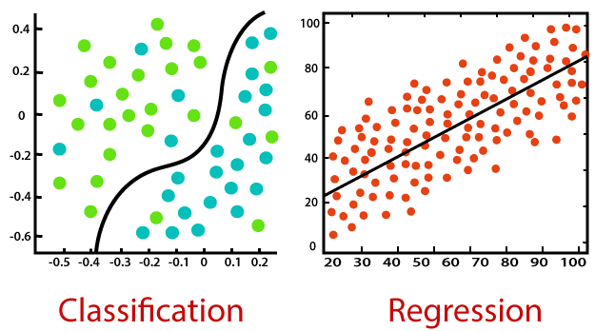
Logistic Regression is a statistical approach and a Machine Learning algorithm that is used for classification problems and is based on the concept of probability. It is used when the dependent variable (target) is categorical.
It is widely used when the classification problem at hand is binary; true or false, yes or no, etc. For example, it can be used to predict whether an email is spam (1) or not (0).
A person will survive this accident or not, The student will pass this exam or not. The outcome can either be yes or no (2 outputs). This regression technique is similar to linear regression and can be used to predict the Probabilities for classification problems.

Logistics regression uses the sigmoid function to return the probability of a label.

Sigmoid Function
Sigmoid Function is a mathematical function used to map the predicted values to probabilities. The function has the ability to map any real value into another value within a range of 0 and 1.
def sigmoid(z):
return 1.0 / (1 + np.exp(-z))
where z is dot product of coefficients and features matrix
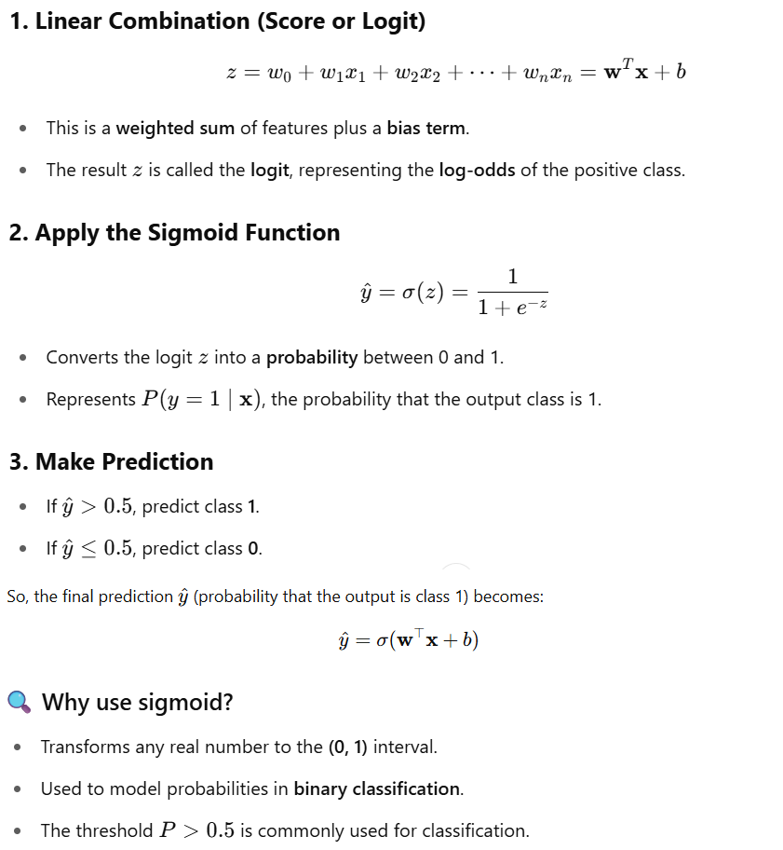

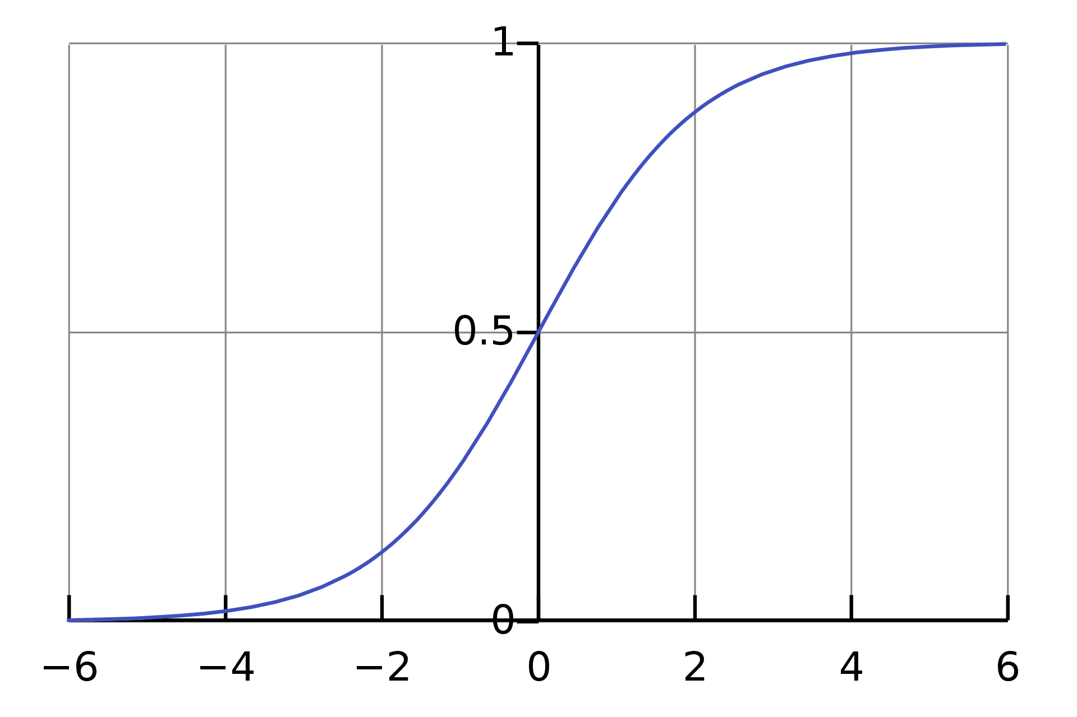
The rule is that the value of the logistic regression must be between 0 and 1. Due to the limitations of it not being able to go beyond the value 1, on a graph it forms a curve in the form of an "S". This is an easy way to identify the Sigmoid function or the logistic function.
In regards to Logistic Regression, the concept used is the threshold value. The threshold values help to define the probability of either 0 or 1. For example, values above the threshold value tend to 1, and a value below the threshold value tends to 0.

Type of Logistic Regression

- Binary Logistic Regression
It is used to predict the probability of a binary outcome, such as yes or no, true or false, or 0 or 1. For example, it could be used to predict whether a customer will churn or not, whether a patient has a disease or not, or whether a loan will be repaid or not.
- Multinomial Logistic Regression
Multinomial logistic regression is used to predict the probability of one of three or more possible outcomes, such as the type of product a customer will buy, the rating a customer will give a product, or the political party a person will vote for.
This means that there can be 3 or more possible unordered types of the dependent variable, such as "cat", "dogs", or "sheep"
- Ordinal Logistic Regression
It is used to predict the probability of an outcome that falls into a predetermined order, such as the level of customer satisfaction, the severity of a disease, or the stage of cancer.
This means that there can be 3 or more possible ordered types of dependent variables, such as "low", "Medium", or "High".

Linear and Logistic Regression
Linear Regression is similar to Logistic Regression but different.
Linear Regression assumes that there is a linear relationship between dependent and independent variables. It uses the line of best fit that describes two or more variables. The aim of Linear Regression is to accurately predict the output for the continuous dependent variable.
However, Logistic regression predicts the probability of an event or class that is dependent on other factors, therefore the output of Logistic Regression always lies between 0 and 1.
To find out more about the difference between Linear and Logistic Regression

Classification Regression

Cost Function
A Cost Function is a mathematical formula used to calculate the error, it is a difference between our predicted value and the actual value. It simply measures how wrong the model is in terms of its ability to estimate the relationship between x and y.
The value of the Cost Function can also be referred to as cost, loss, or error. Within Logistic Regression, the Cost Function we use is called Cross-Entropy, also known as Log Loss. The formula for this is:
If you would like to know more about different types of Cost Functions, click on this link.

Cross-Entropy
Cross-entropy loss, or log loss, measures the performance of a classification model whose output is a probability value between 0 and 1. Cross-entropy loss increases as the predicted probability diverges from the actual label. So predicting a probability of .012 when the actual observation label is 1 would be bad and result in a high loss value. A perfect model would have a log loss of 0.
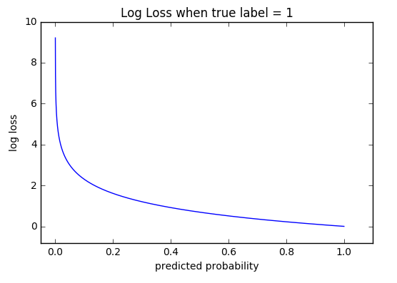
The graph above shows the range of possible loss values given a true observation (isDog = 1). As the predicted probability approaches 1, log loss slowly decreases. As the predicted probability decreases, however, the log loss increases rapidly. Log loss penalizes both types of errors, but especially those predictions that are confident and wrong!
Cross-entropy and log loss are slightly different depending on context, but in machine learning when calculating error rates between 0 and 1 they resolve to the same thing.
In binary classification, where the number of classes M equals 2, cross-entropy can be calculated as:

Gradient Descent
In order to minimize our cost, we use Gradient Descent which estimates the parameters or weights of our model.

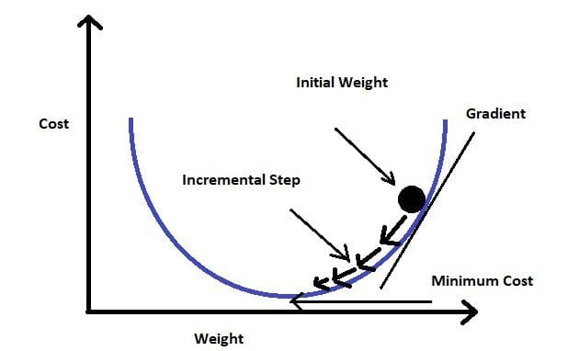

So, what do we need to apply Gradient Decent
- Initial values of ‘m’ and ‘b’ we can take zero or any random value
- Loss function
- Differentiation of loss function w.r. to ‘m’ and ‘b’
- Calculate new m and b using formula given below

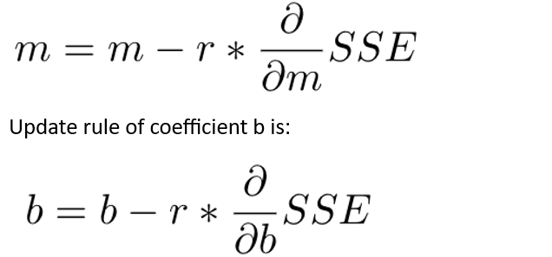
So here SSE we can replace with log loss mean error function in case of logistic classification regression as

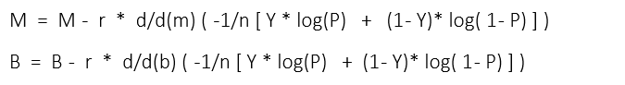

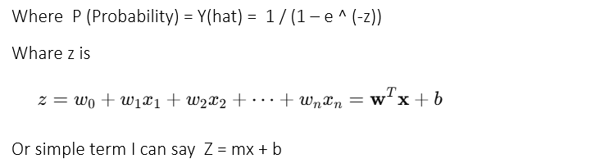
But for gradient calculation we required the differentiation of log loss function and the differentiation of entropy (p) , entropy is denoted as sigma sign
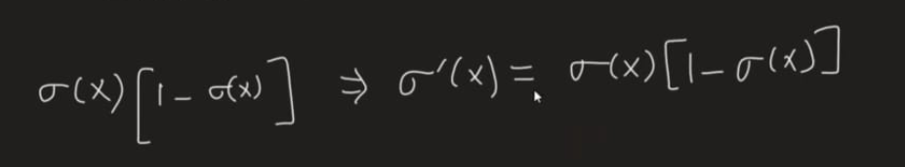
Actually, this differentiation is w.r. to X means here z which is [ e^(-z) ]
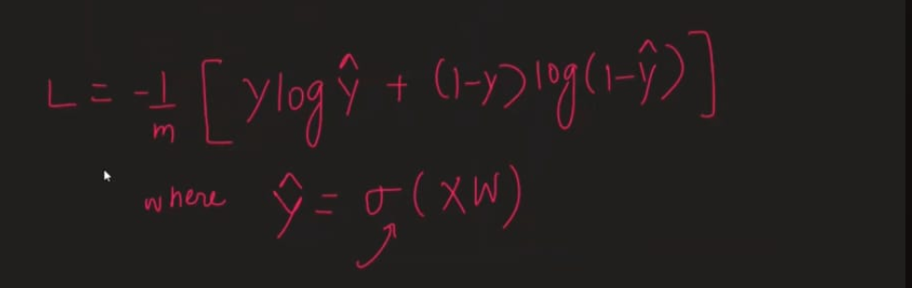

Where X & W are in matrix form as below


Let’s understand Logistic regression formulas using gradient decent

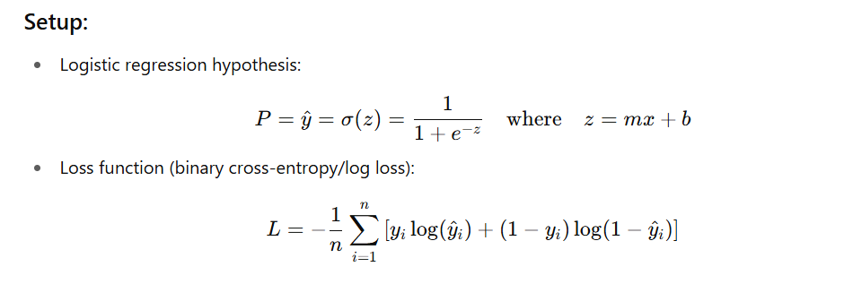
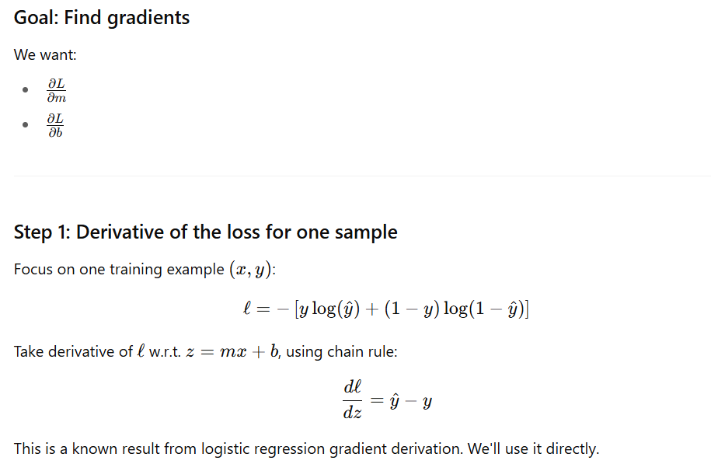
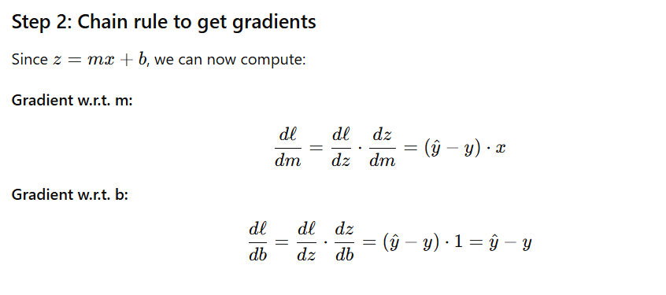
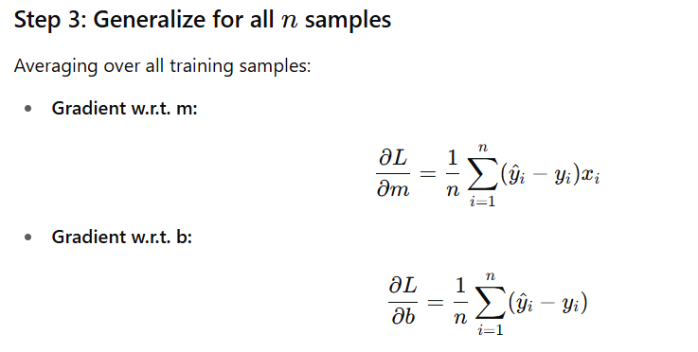
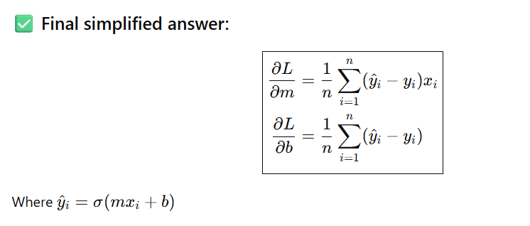
Deep dive differentiation
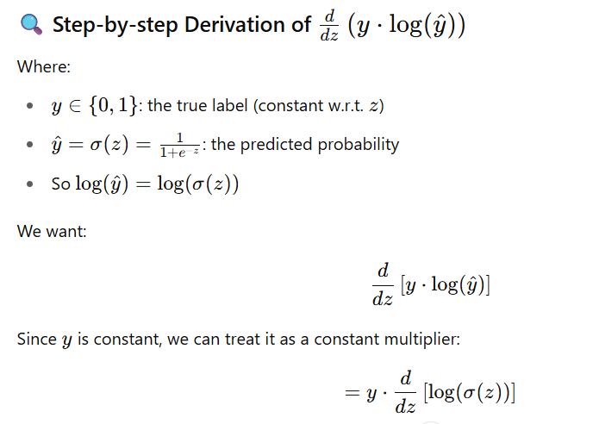
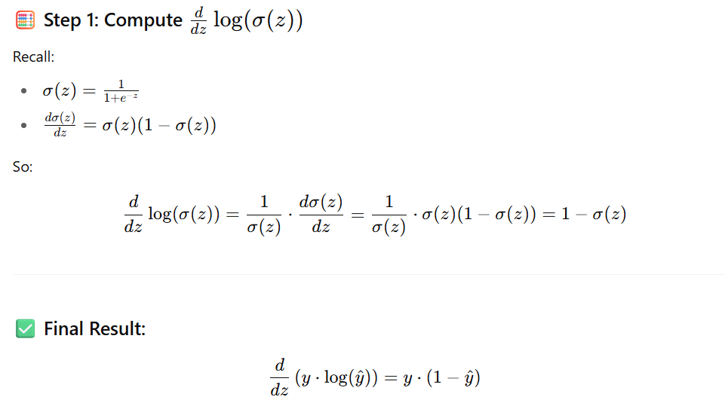
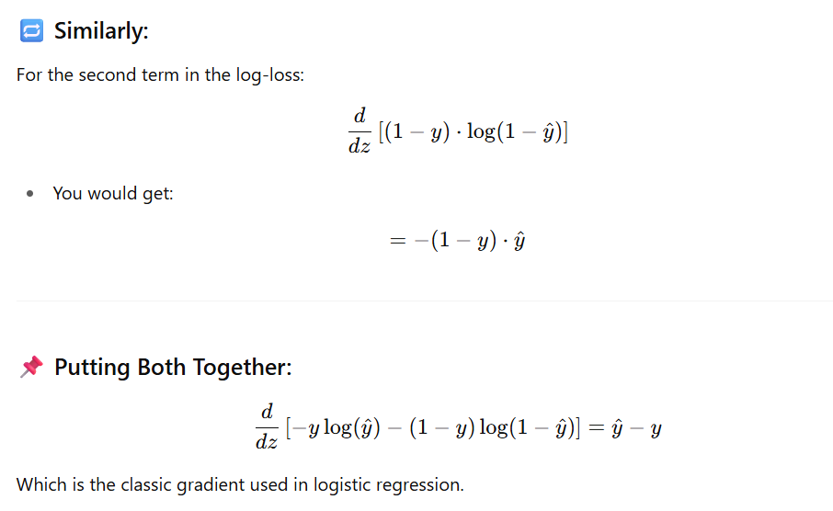

What is the Perceptron Model in Machine Learning?
The Perceptron model is a type of artificial neuron that functions as a linear binary classifier. Its purpose is to classify data points into one of two categories by learning a decision boundary from labeled training data. The model is trained using supervised learning, where the inputs and their corresponding outputs are provided. The Perceptron model calculates the weighted sum of input values, applies an activation function, and produces a binary output. If the output meets or exceeds a specific threshold, it is classified into one category; otherwise, it falls into the other category. This process makes the Perceptron particularly useful in tasks such as binary classification in datasets like spam detection or sentiment analysis. Although it is limited to linear separability, the Perceptron remains a fundamental algorithm for understanding neural networks.
Basic Components of a Perceptron
The Perceptron consists of several key components that work together to process input data and generate an output. The main components include:
- Input layer: The input layer consists of feature values or data points that the Perceptron will classify. Each input is assigned a corresponding weight.
- Weights: Weights determine the importance of each input in the classification process. The model adjusts these weights during training to improve accuracy.
- Bias: The bias term helps the Perceptron shift the decision boundary, improving flexibility in data classification.
- Activation function: The activation function, such as a step function or sigmoid function, determines the output based on the weighted sum of the inputs.
- Output: The output is the final result of the Perceptron’s decision, typically a binary value (0 or 1) in the case of binary classification.
Together, these components allow the Perceptron to learn from data, adjust its parameters, and generate predictions.
How Does the Perceptron Work?
The Perceptron model operates in a step-by-step process that involves computing the weighted sum of inputs, applying an activation function, and classifying the output. This process allows the model to differentiate between two classes based on the input data.
- Initialize Weights and Bias: The model begins by assigning random weights to the inputs and setting a bias value.
- Compute Weighted Sum: For each input, the Perceptron computes the weighted sum of the input values and adds the bias term. Mathematically, this can be represented as:where WWW represents the weights, XXX represents the inputs, and bbb is the bias.
- Apply Activation Function: The weighted sum is then passed through an activation function. If the result meets a certain threshold, the output is classified as 1; otherwise, it is classified as 0. The step function is a common activation function used for this purpose:
- Update Weights: During training, the model compares the predicted output to the actual output and adjusts the weights using a learning rule (typically gradient descent) to reduce the error.
- Repeat: This process is repeated for multiple iterations until the model’s predictions align with the actual outputs.

Types of Perceptron Models
Single-Layer Perceptron Model
The single-layer Perceptron is the most basic form of the Perceptron algorithm. It consists of only one layer of output neurons that are directly connected to input features. This model can only handle linearly separable data, meaning it can draw a straight line to classify data points into two categories. The mathematical formulation for the single-layer Perceptron involves computing the weighted sum of inputs and applying an activation function to determine the output. However, it cannot solve more complex problems that involve non-linear data, such as the XOR problem.
Multi-Layer Perceptron (MLP)
The Multi-Layer Perceptron (MLP) is an extension of the Perceptron model, introducing one or more hidden layers between the input and output layers. These hidden layers allow MLPs to handle non-linear data by using more complex activation functions like the sigmoid or ReLU (Rectified Linear Unit). The MLP employs backpropagation, a learning algorithm that adjusts weights across all layers to minimize prediction errors. MLPs are the foundation for modern deep learning models and are capable of solving more complex classification and regression tasks.
Perceptron Function
​​The mathematical function of the Perceptron can be expressed as:
Where:
- W is the weight vector
- X is the input vector
- b is the bias
- activation is the function that determines the output, such as the step function or sigmoid function
The activation function plays a crucial role in determining the output. For example, the step function outputs either 0 or 1 based on the threshold, while the sigmoid function provides a smoother transition between 0 and 1, making it suitable for more complex tasks.
Characteristics of Perceptron
The Perceptron model possesses several notable characteristics:
- Simplicity: The model is easy to understand and implement, making it an excellent starting point for learning about neural networks.
- Efficiency: It is efficient when working with linearly separable data, as it quickly converges to a solution.
- Limitations: The Perceptron can only solve problems with linear decision boundaries, making it unsuitable for more complex tasks.
- Applications: Perceptrons are used in various fields such as binary classification, image recognition, and speech processing.
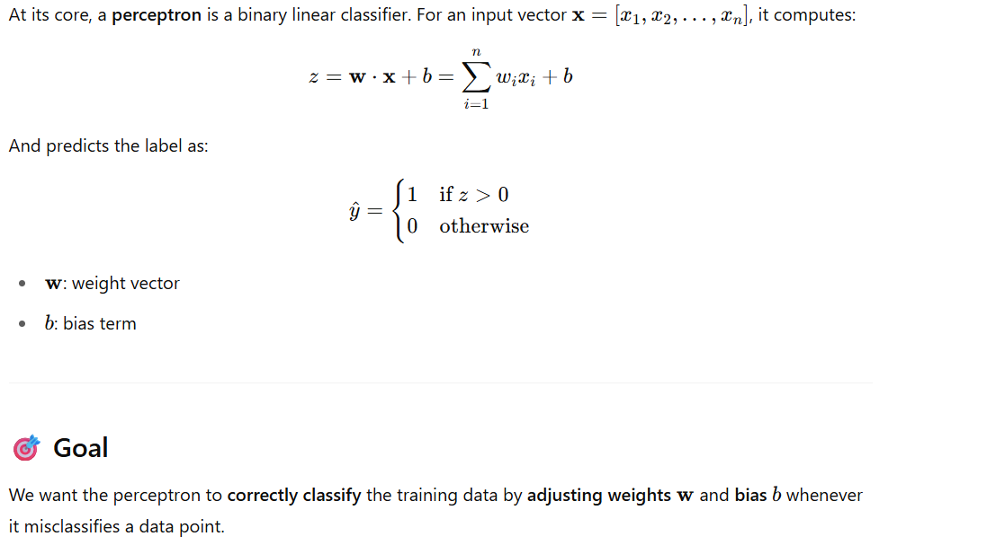
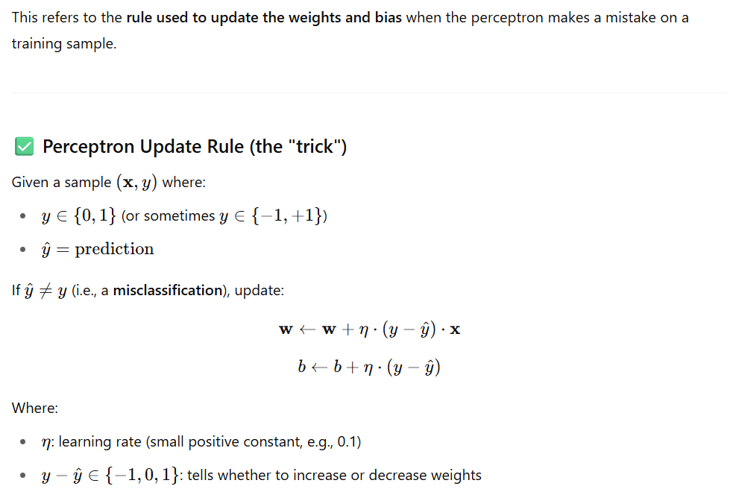

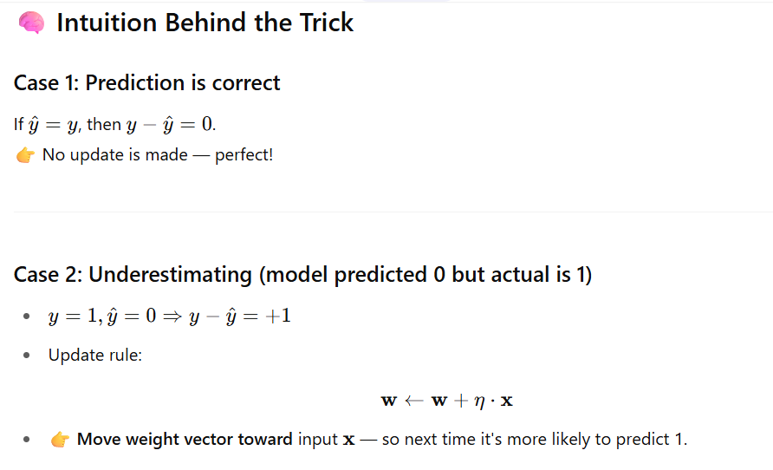
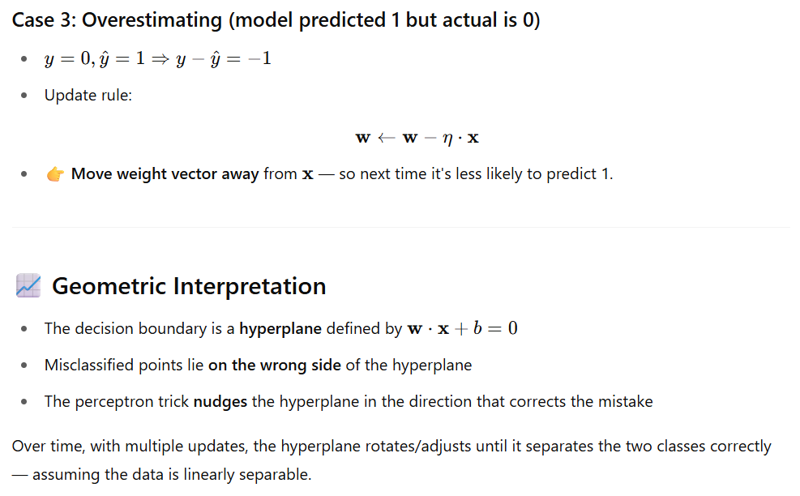
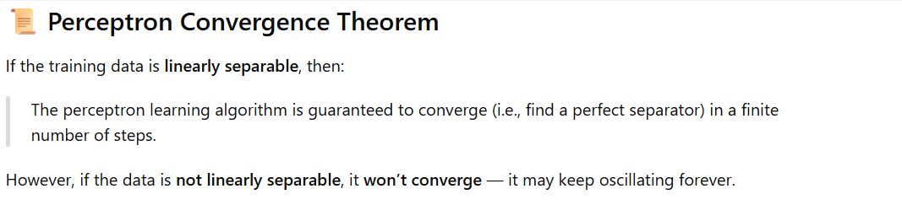
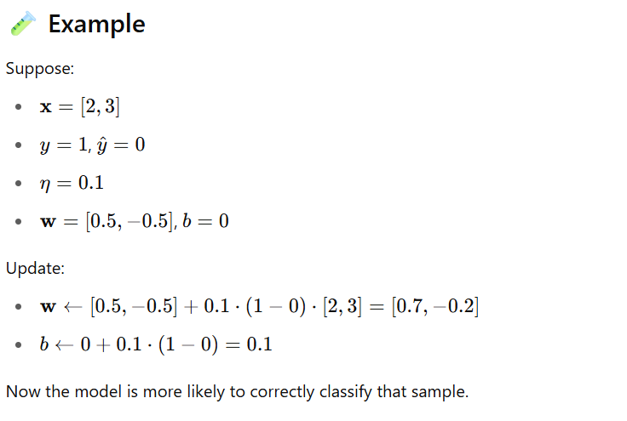
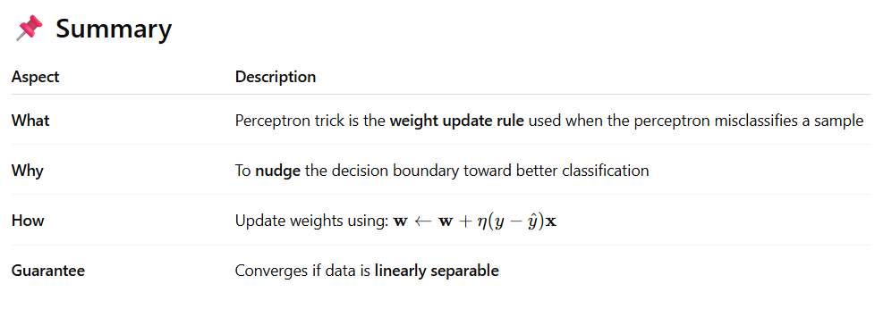

https://www.analyticsvidhya.com/blog/2022/02/decoding-logistic-regression-using-mle/
https://arunaddagatla.medium.com/maximum-likelihood-estimation-in-logistic-regression-f86ff1627b67

Maximum Likelihood Estimation (MLE) — Explained Simply

🔍 What is the Maximum Likelihood concept?
Maximum Likelihood Estimation (MLE) is a statistical method used to estimate the parameters of a model by maximizing the likelihood that the observed data was generated by the model.
Think of it this way:
“Given the data we’ve seen, what values of the model parameters make this data most probable?”

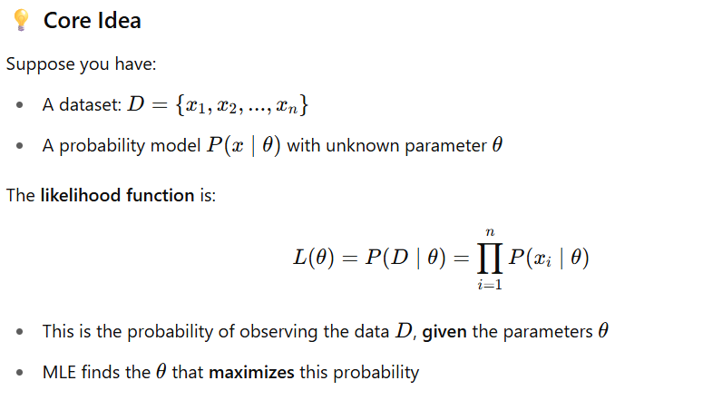
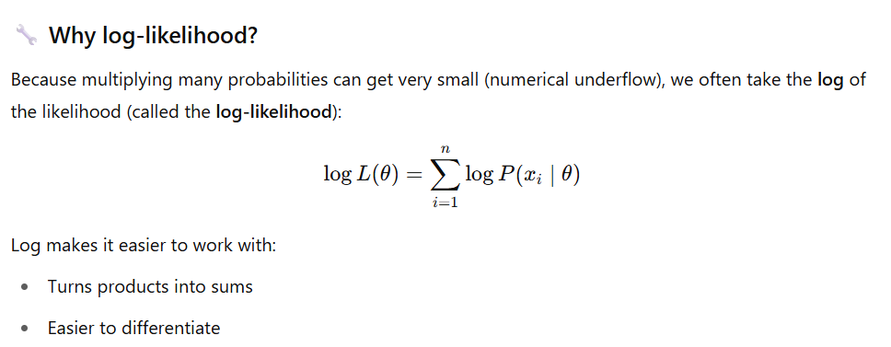
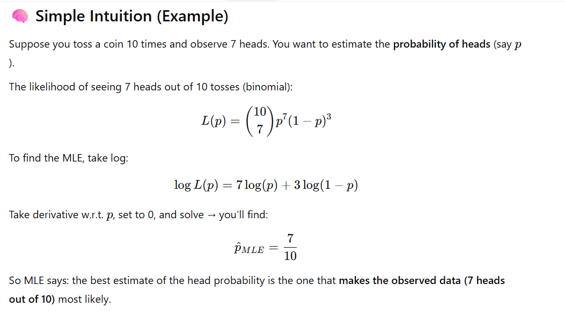
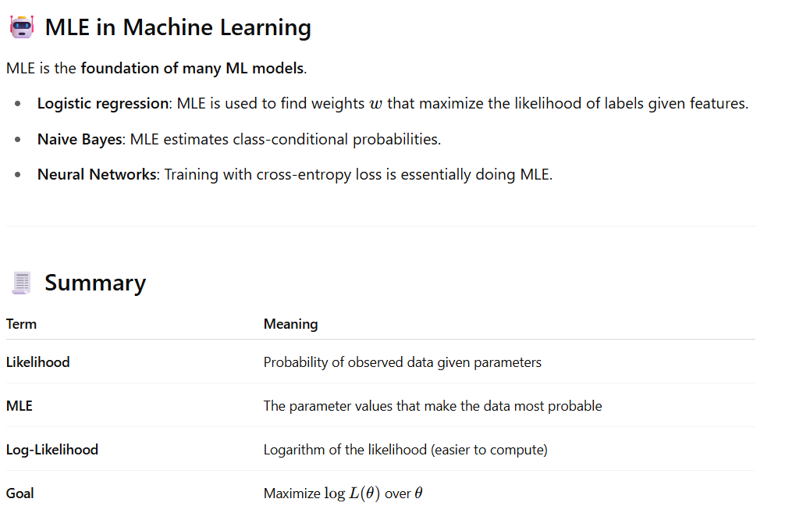

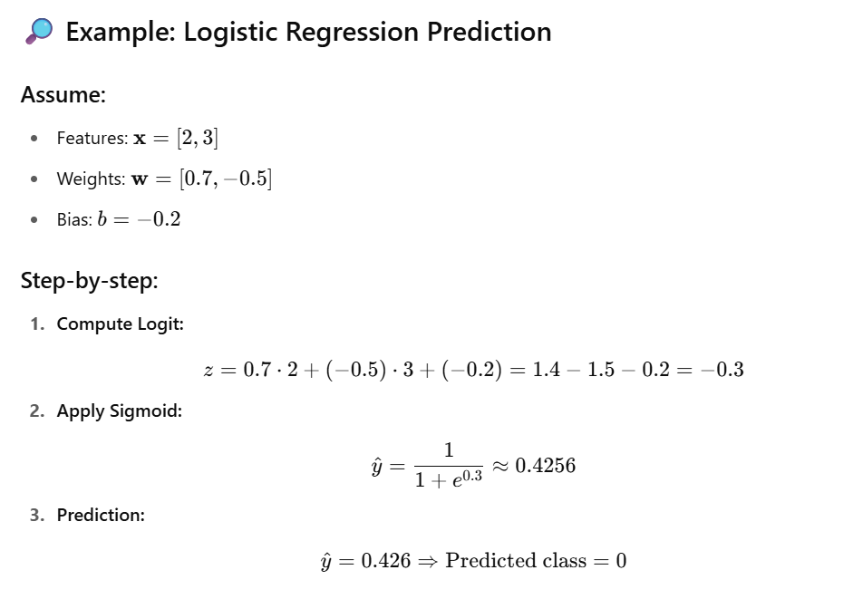
📌 Interpretation of Weights
- Positive weight increases the probability of class 1 as the feature increases.
- Negative weight decreases the probability of class 1.
- Larger magnitude = more influence on the prediction.

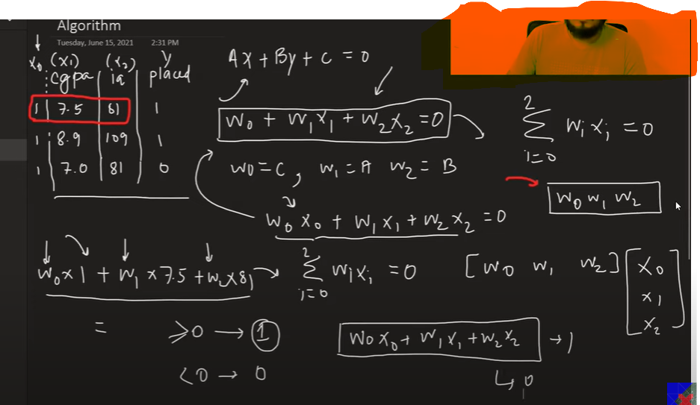

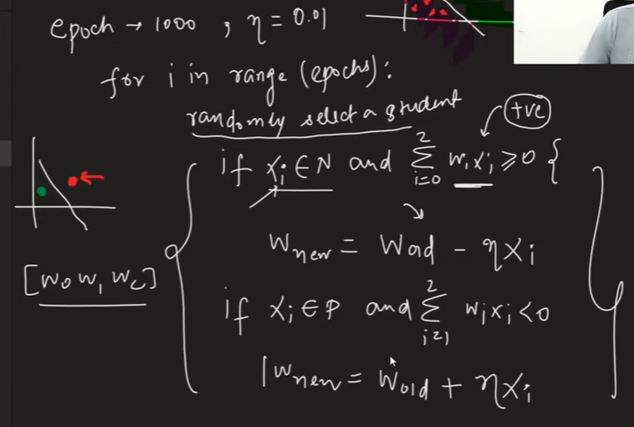

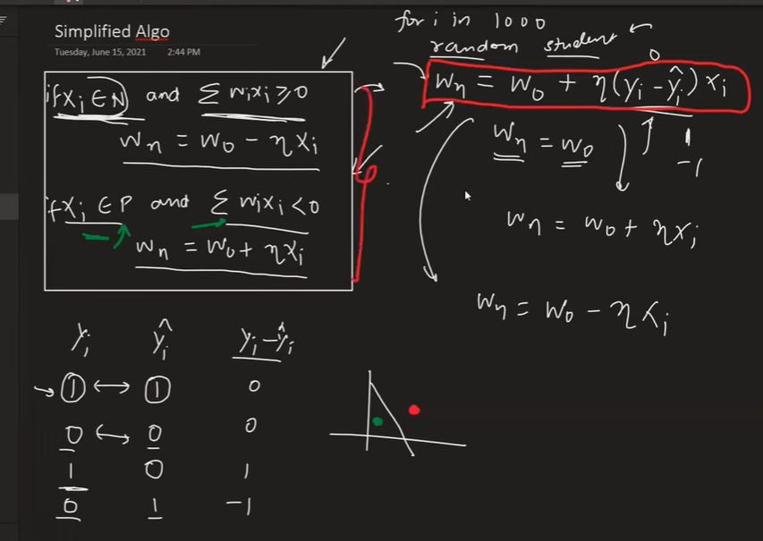

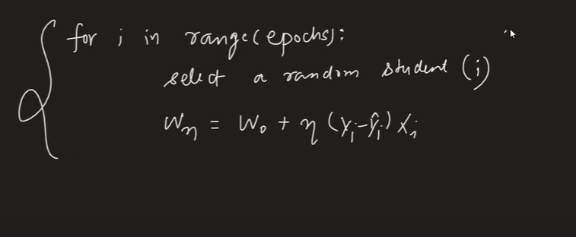

This approach have some issues
Use sigmoid instead of step function
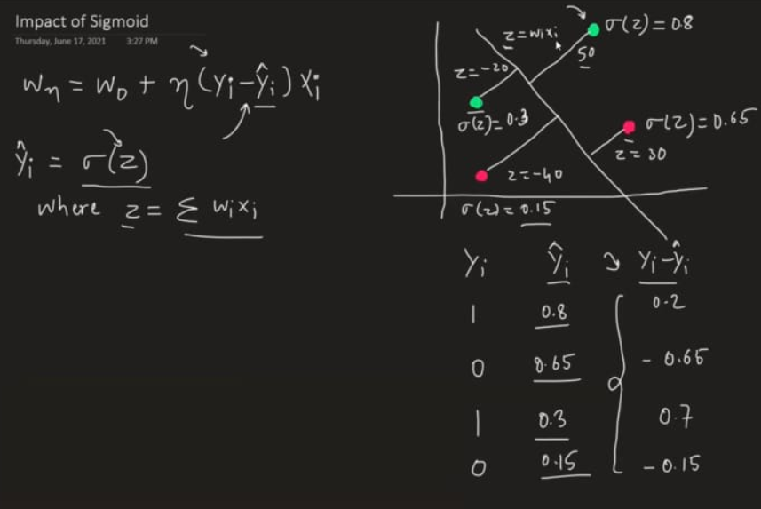

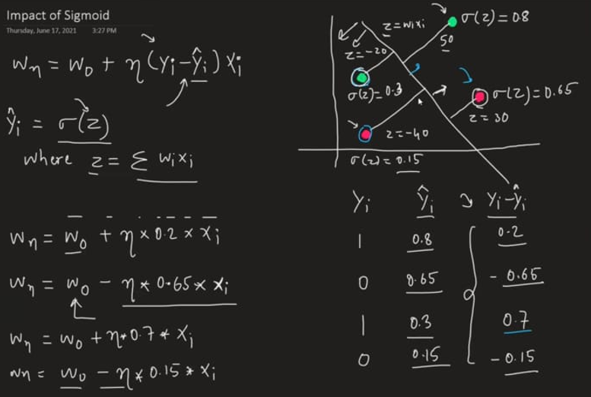

Using sigmoid still we are not getting perfect predicted line which can divide both blue and green point from the middle so we need a loss function to calculate minima which can tell this line has the minimum loss

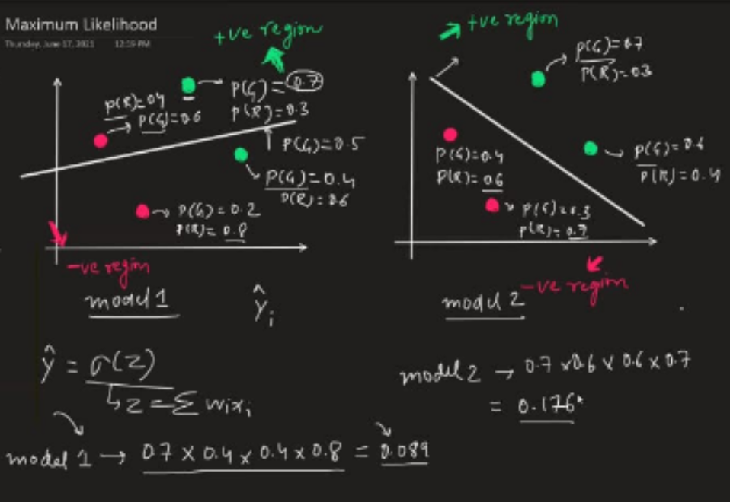

Log loss function
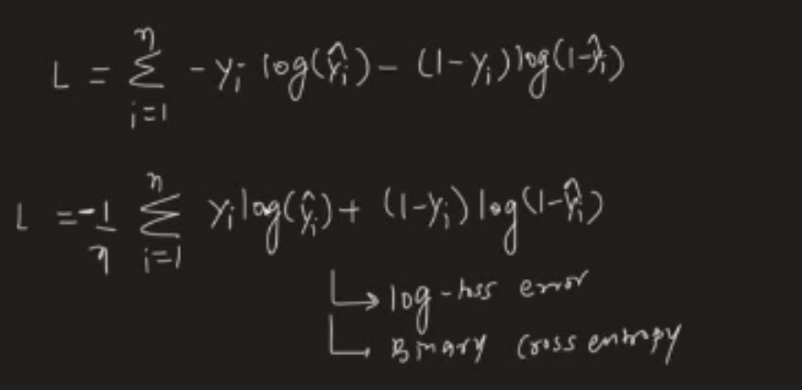

Derivative of log loss function (using gradient decent)
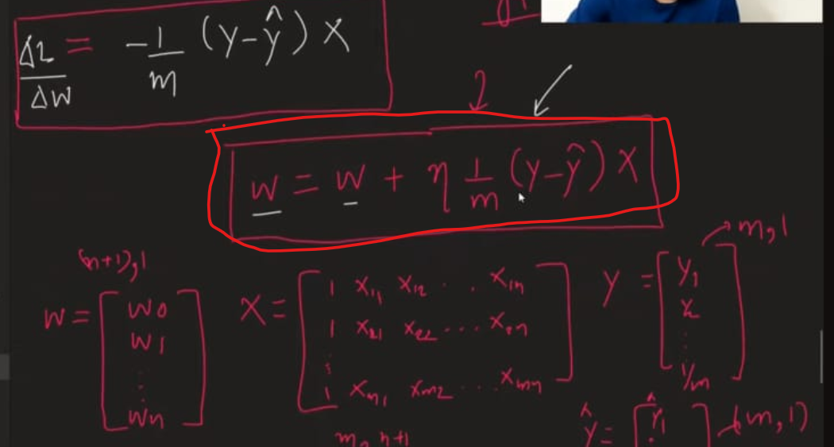

We can use this formula to write python code which will work like sklearn

Code - https://github.com/campusx-official/100-days-of-machine-learning/tree/main/day58-logistic-regression

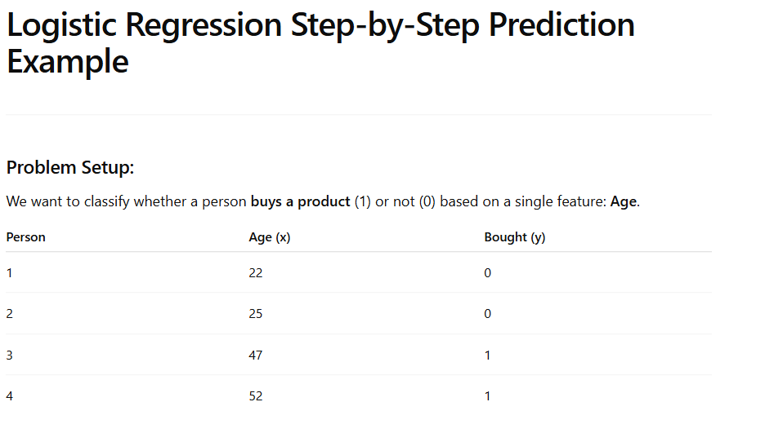

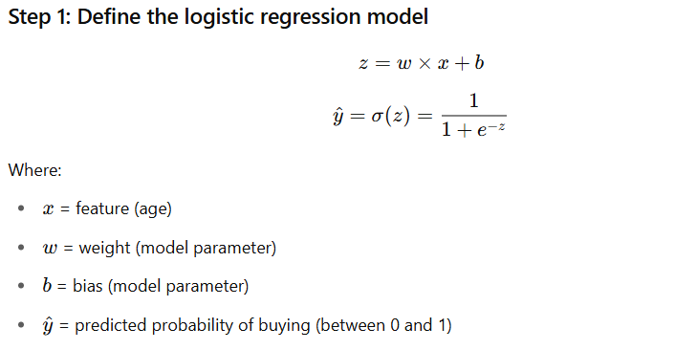
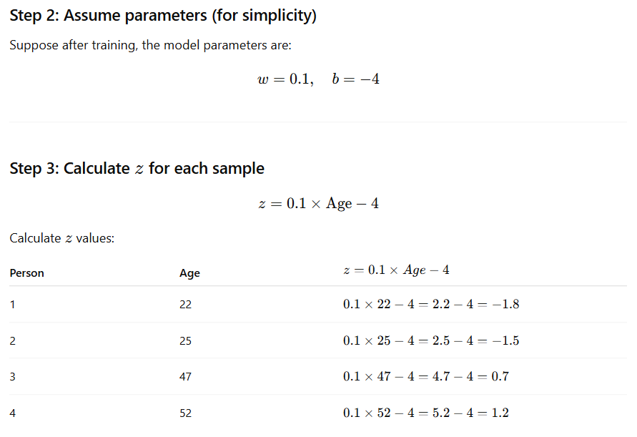
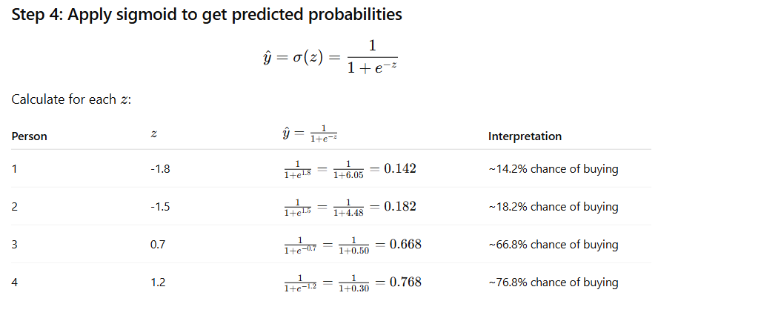
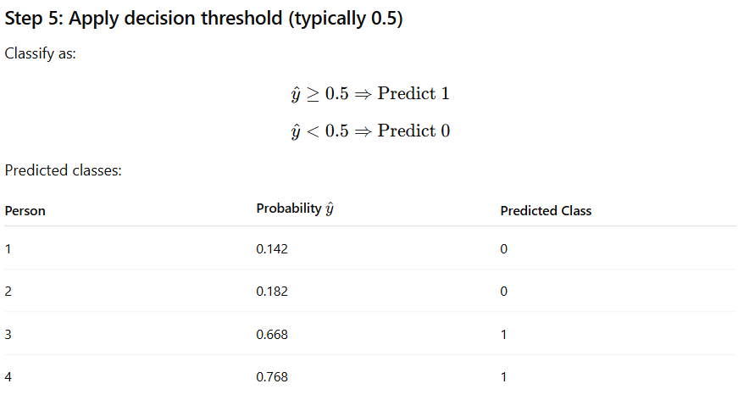
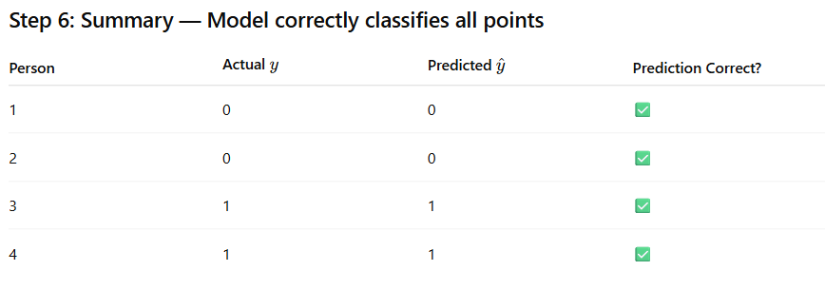

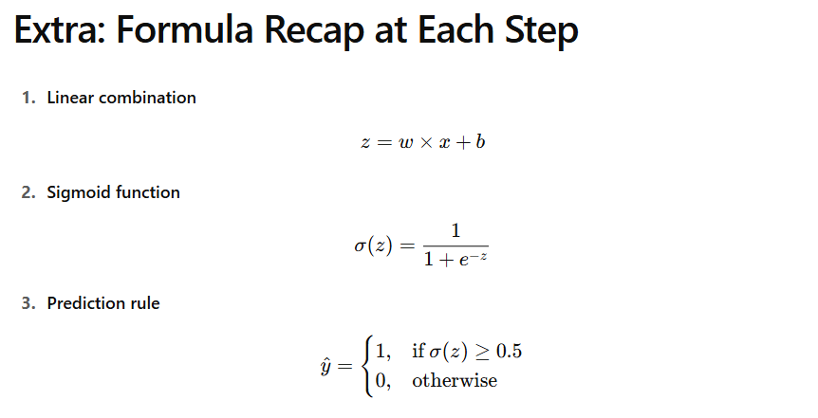

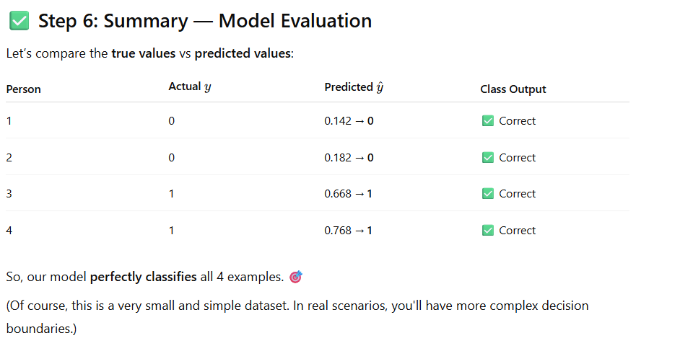

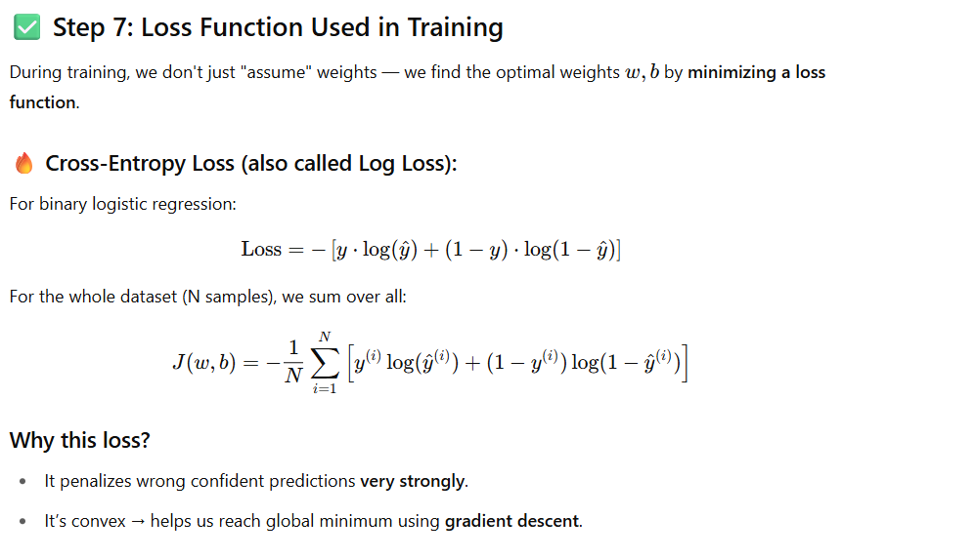

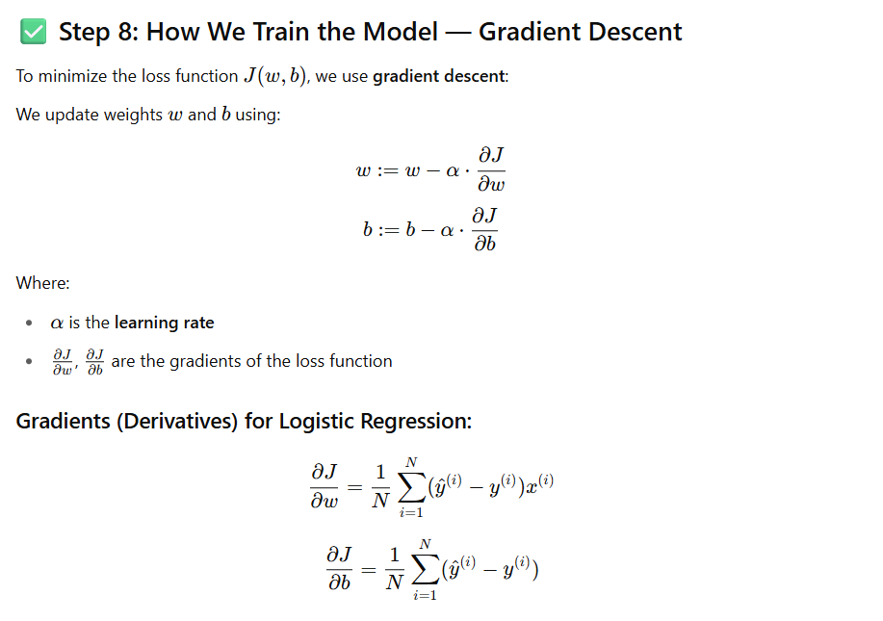

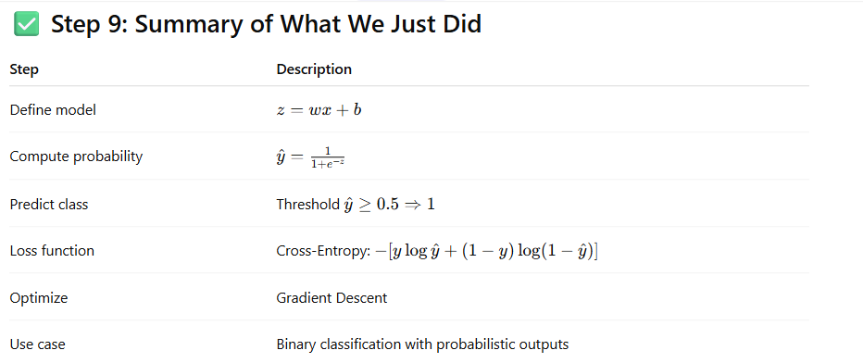
Bonus Intuition
Imagine:
- Your sigmoid output is 0.95, but true label is 0 → model is overconfident and wrong → high penalty in loss.
- Your sigmoid output is 0.6 and true label is 1 → correct, but not confident → moderate loss.
This encourages the model to improve both accuracy and confidence during training.

🎯 Final Thoughts
Logistic regression is powerful not because it models non-linearity, but because:
- It’s interpretable
- Works well for linearly separable classes
- Outputs probabilities you can calibrate
- Scales well to large datasets
- Forms the base for many advanced models (e.g., neural networks)

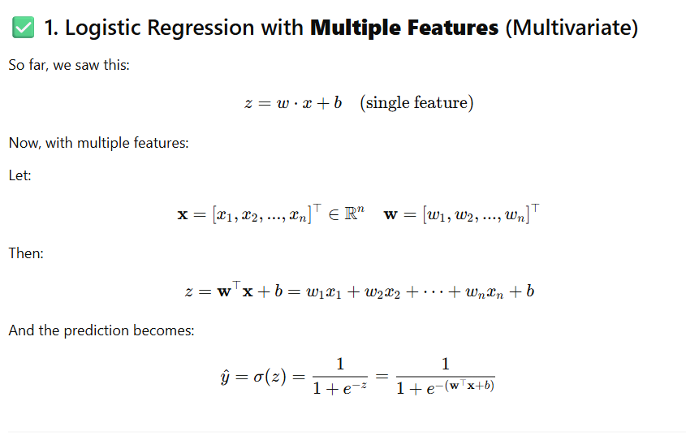

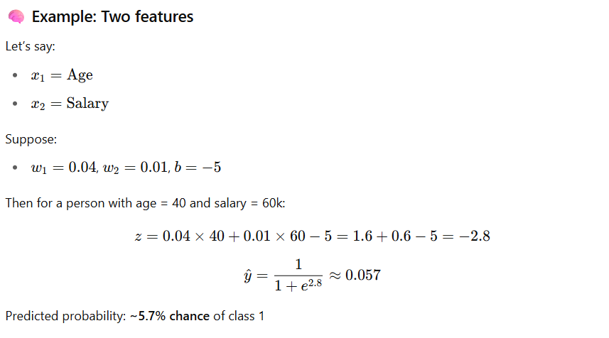

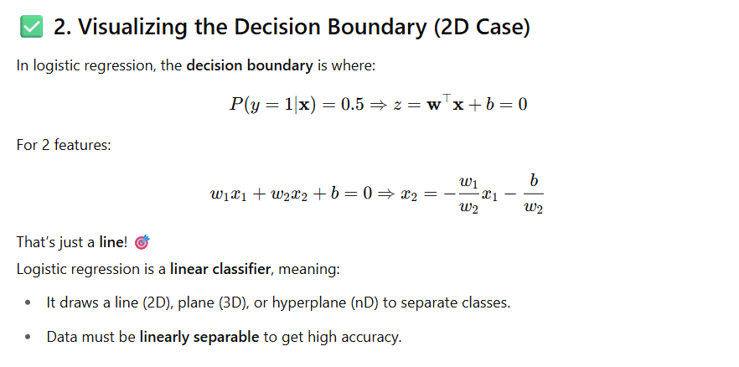

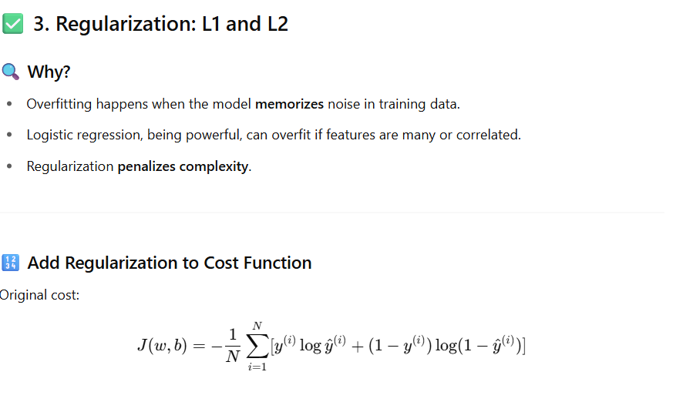
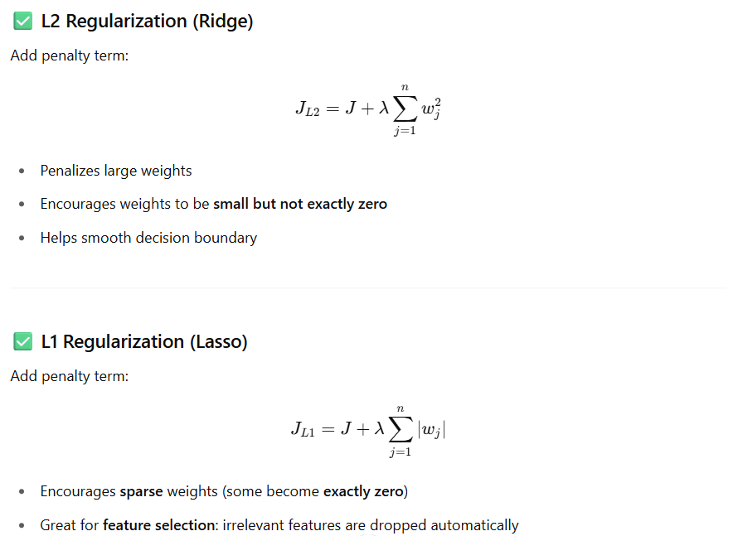

1. Common Logistic Regression Hyperparameters (Overview)
Hyperparameter | Description
penalty | Type of regularization ('l1', 'l2', 'elasticnet', or 'none')
C | Inverse of regularization strength (smaller → more regularization)
solver | Optimization algorithm ('liblinear', 'saga', 'lbfgs', etc.)
max_iter | Maximum number of iterations for convergence
fit_intercept | Whether to include a bias term (intercept)
class_weight | Handles class imbalance by assigning weights to classes
tol | Tolerance for stopping criteria in optimization
multi_class | Strategy for multi-class classification ('ovr', 'multinomial')
l1_ratio | Mixing ratio for L1 vs L2 (used only when penalty='elasticnet')
random_state | Seed for randomness (important for reproducibility)

2. Explanation with Scikit-learn’s LogisticRegression (sklearn.linear_model.LogisticRegression)
🔹 penalty
- Options: 'l1', 'l2', 'elasticnet', 'none'
- Default: 'l2'
- Use:
  - 'l1': Feature selection (sparse models)
  - 'l2': Ridge regularization
  - 'elasticnet': Combination of L1 + L2
  - 'none': No regularization
🧠 Note: Not all solvers support all penalty types!
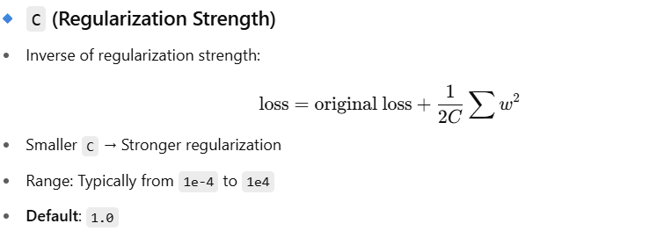
solver
Solver | Supports Penalties | Suitable For
'liblinear' | 'l1', 'l2' | Small datasets, binary, OVR
'lbfgs' | 'l2' | Large datasets, multiclass
'saga' | 'l1', 'l2', 'elasticnet', 'none' | Large-scale, sparse
'newton-cg' | 'l2', 'none' | Multiclass (better than lbfgs in some cases)

🔹 multi_class
- 'ovr' = One-vs-Rest (default for solvers except 'lbfgs')
- 'multinomial' = Softmax-based multiclass logistic regression
- 'auto' = Automatically chooses based on solver

🔹 max_iter
- Max number of optimization iterations (default: 100)
- Increase this if solver doesn’t converge

🔹 fit_intercept
- True: Learn bias term bbb
- False: Don’t learn intercept

🔹 class_weight
- 'balanced' or custom dictionary like {0: 1, 1: 3}
- Useful for imbalanced datasets

🔹 l1_ratio (Elastic Net only)
- Range: 0 (L2) to 1 (L1)
- Only used when penalty='elasticnet' and solver is 'saga'

✅ 3. Suggested Configurations
🔸 Binary classification with regularization:
python
CopyEdit
LogisticRegression(penalty='l2', C=1.0, solver='lbfgs')
🔸 Sparse feature selection with L1:
python
CopyEdit
LogisticRegression(penalty='l1', solver='liblinear', C=0.1)
🔸 Large-scale, elastic net:
python
CopyEdit
LogisticRegression(penalty='elasticnet', solver='saga', l1_ratio=0.5)
🔸 Imbalanced classes:
python
CopyEdit
LogisticRegression(class_weight='balanced')

✅ 4. Tuning Tips
- Always scale your features (StandardScaler or MinMaxScaler)
- Use cross-validation to tune C, penalty, and solver
- Monitor convergence warnings — increase max_iter if needed
- Use grid search or randomized search for hyperparameter tuning

✅ 5. Visualization of Effect of C
C Value | Effect on Model | Interpretation
0.001 | Very regularized | Simpler, low variance, high bias
1.0 | Medium regularized | Balanced
1000 | Weak regularization | Model fits training data tightly

Tips for deeply practicing code:

Here are some highly practical suggestions to strengthen your understanding and skills in logistic regression through coding:

✅ 1. Reimplement Logistic Regression from Scratch
- Implement it with and without bias terms.
- Try different optimization methods:
  - Batch Gradient Descent
  - Stochastic Gradient Descent (SGD)
  - Mini-batch Gradient Descent
- Add support for:
  - Regularization (L1, L2)
  - Learning rate decay

✅ 2. Practice on Classic Datasets
Use scikit-learn.datasets or open datasets from Kaggle:
- Iris (binary and multiclass)
- Titanic dataset (survival prediction)
- Breast Cancer Wisconsin
- Digits dataset (use logistic regression with softmax for multi-class)
👉 Challenge: Train logistic regression on each dataset from scratch and compare with sklearn.linear_model.LogisticRegression.

✅ 3. Visual Projects to Boost Intuition
- 2D/3D decision boundary visualization (like you just did).
- Plot loss vs epochs to track training progress.
- Show probability contours in 2D space for two features.

✅ 4. Play with Synthetic Data
Use sklearn.datasets.make_classification() or make_moons() and:
- Tune number of informative features.
- Add noise and test regularization strength.
- Explore class imbalance using class_weight.

✅ 5. Mini Projects
Here are some cool mini-projects:
Project | Concepts
Spam vs Ham Email Classification | Feature engineering + binary classification
Image classifier (binary: cat vs dog) using logistic regression on downsampled pixels | High-dimensional input
Heart Disease Prediction | Real-world dataset with feature scaling & preprocessing
Ad Click Prediction | Explore feature encoding for categorical variables

✅ 6. Kaggle Practice Notebooks
Search for:
- Titanic (Beginner)
- Breast Cancer
- Customer Churn
👉 Try: “Can I beat scikit-learn’s logistic regression with my own implementation?”

✅ 7. Next Steps to Explore
- Implement Multinomial Logistic Regression (Softmax).
- Try logistic regression using PyTorch or TensorFlow.
- Build a Flask API for your logistic regression model and test it with requests.

